SHÚSHIN KAI GOJU RYU KARATE
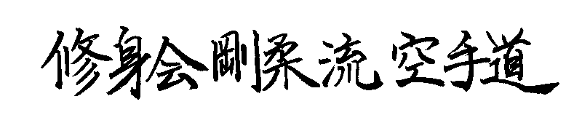

JANUARY, 2022 No. 34

kiai !!!!

THE 2021 YEAR
Well, in 2021 it was like “, here we go again” with Covid19 restrictions and lockdowns. We ended the year holding the world record for being the longest lockdown city in the world. Boy, that’s a prize I don’t think sits well with “World’s Most Liveable City”.

Fortunately, restrictions were relaxed in time for us to have our usual combined dojo gradings at Hillside on December 16th.

GRADINGS
It was busy night because apart from our usual kyu gradings, we also held our Black Belt gradings. Normally our Black Belt grading are held at our Annual Training Day in October. However, for the last 2 years the Training Day has been cancelled because of lockdowns.

The Kyu grading results are;-

Promoted to 1st Kyu Brown Belt
Chandralal Somarathna (Hillside)

Promoted to 3rd kyu Kyu Brown Belt
Sanindu Somarathna (Hillside)
Michael McLaughlin (Hillside)

Promoted to 4th Kyu (Green Belt)
Isha Bangara (Hillside)
Gabi Stojkoska (Hillside)

Promoted to 6th Kyu Orange Belt
Tracy Raleigh (Westmeadows)
Hayden Raleigh (Westmeadows)

Promoted to 7th Kyu Yellow Belt
Joe Sultana (Hillside)

Promoted 8th Kyu (White Belt with stripe)
Ken Duong (Hillside)
Ojas Gaddam (Westmeadows)
Lohit Koppla (Hillside)

New belts and Certificates will be awarded on the first night back in class in 2022.

ZOOM CLASSES IN LOCKDOWN
Because we had some experiences with lockdowns we moved pretty quickly to organise Zoom classes.

Our Black Belts all participated in running small group classes for members. At one stage we were having 10 or 11 classes per week! Because our Black Belts all volunteered to help, we had the ability to run classes according to the kyu grade of members. Some senior Brown Belts were attending classes every night and unassigned Black Belts attended multiple classes to help out. Wednesday night was a Black Belt only class, and Tuesdays we held a special class for Black Belts preparing for upgrades. I would particularly like to thank Sean who organized a special Saturday morning basics class for our juniors. Asanka attended these sessions too.

It showed which of our members were really supporting the club, and trying hard to improve and progress. Most of the members in the kyu grade area were rewarded with a grading at the end of the year.
So that was our 2020!! Even our Annual General Meeting was held on Zoom, so thank goodness for technology. Although many martial arts schools suffered greatly through the loss of students and income, we as a not-for-profit group survived basically intact, and in a good financial position.

BLACK BELT GRADING
On the last night for 2021, held at the Hillside Dojo, we promoted 3 more members to 1st Dan (Shodan) Black Belt.
After years of study, practice, disappointment, ups and downs and quite a bit of critical feedback, Anthony and Tara Balia from the Westmeadows dojo, and Jordan Saykarosky from the Hillside dojo achieved their coveted Black Belts. The preparation for them was different because of limited face to face training opportunities, but the test was the same as for previous Black Belt gradings. Due to government imposed “no contact” requirements, we did not have sparring, but we actually increased the emphasis on form, kata, attendance and contribution to the club. At the grading their assignments “What Karate Means to Me” were not read out as we usually do, because of time restrictions. These assignments were accepted and can now be viewed on our website. They are also reprinted at the end of this newsletter. I recommend everybody read these assignments for a good insight into their journey from White Belt to Black Belt!!!

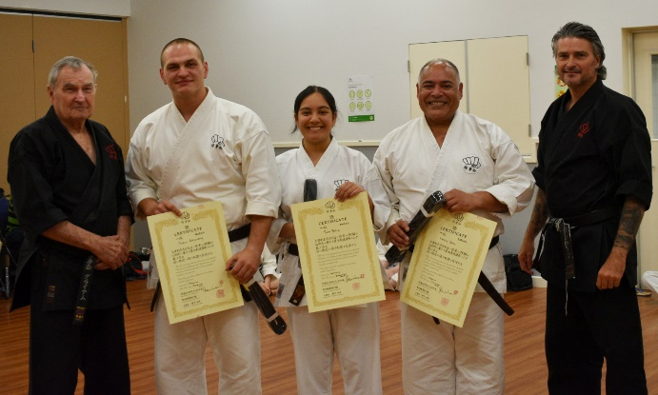
This pic shows Jordan, Tara and Anthony with Graeme Shihan and Lincoln Sensei after receiving their Shodan Certificates and new Black Belts

BLACK BELT PROMOTIONS
This year saw the promotion of Asanka Silva to 3rd Dan (Sandan) and Sean Carville to 2nd Dan (Nidan).
Both Asanka (Ice) and Sean have practiced karate with us for many years and have experienced pretty much all the challenges life can throw at them. They have overcome the challenges with commitment and love of karate. Congratulations, Ice and Sean, Sensei Lincoln and I are very proud of you both.
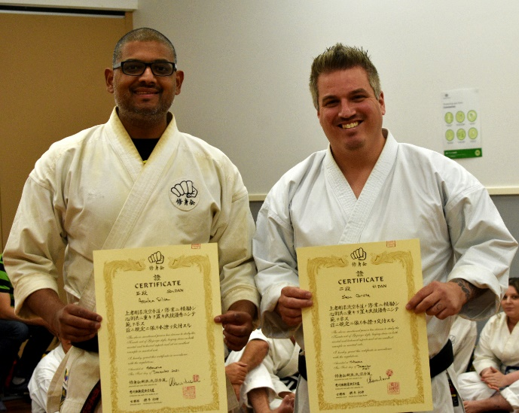
Asanka and Sean proudly displaying their new certificates.

LAST NIGHT OF TRAINING 2021
As mentioned earlier, on December 16th we had our last night of training for the year at the Hillside dojo. It was great to train again with members who had missed months of face-to-face classes just like in the previous year..
This year we were able to bring all our dojos together for the night. We had a kyu grading, and Black Belt promotions which took all night. The evening was so packed with activities our class ran 30 minutes overtime.

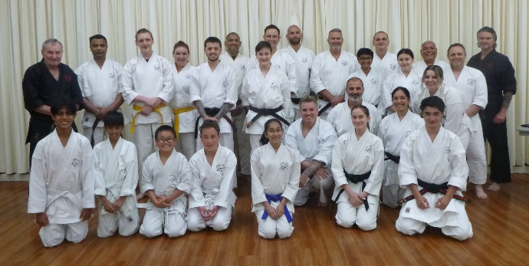
This pic shows the class at the end of 2021

STUDENT OF THE YEAR AWARD
Every year we nominate one student to be awarded our “Student of the Year” award. This year we were really happy to present this award to Daniella Craig from the Hillside dojo. Daniella has grown leaps and bounds and has trained hard all year. Well done!! Keep up the good work and continue to enjoy your karate journey!!
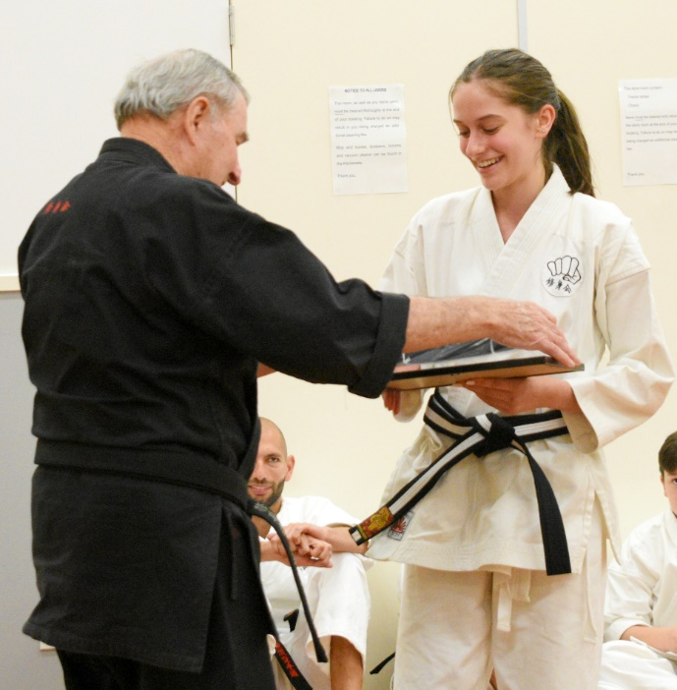
Here is Daniella receiving her “Student of the Year“ award for 2021.

CLUB EVENTS CANCELLED IN 2021
Unfortunately, because of lockdowns we once again had to cancel a number of usual events. We had to cancel our Annual Training Day for the second year, thus meaning our Black Belt gradings had to wait until the end of the year. We also lost our traditional Black Belt Dinner in October. Christmas once again lost its traditional family day picnic. Also 2 regular kyu gradings were cancelled. Let’s hope that some normality will return to us in 2022!!

SENSEI TSUBAMOTO PASSES
On January 21st 2021 our Teacher Sensei Kazunobu Tsubamoto sadly passed away in Tokyo after a long illness. Sensei was a senior student of Sosui Ichikawa, and a 5th generation Bubishi holder from the founder of Goju Ryu. Sensei Tsubamoto was Kaicho of Shigaku Kan. He was the direct teacher of Shihan Graeme and Sensei Lincoln. Several ShushinKai Black Belts travelled to Tokyo with Shihan Graeme to train with Tsubamoto sensei over the years. Sensei and the Shigaku Kan seniors visited us here in Melbourne in 2015 and trained with us. Sensei Lincoln and I last saw Sensei when we went to Tokyo in 2018. We were all devastated and shocked when we learned of Sensei’s passing. Due to border lockdowns we were not able to attend the funeral in Japan but letters Sensei Lincoln and I wrote to Sensei Tsubamoto and his family were translated into Japanese and placed in his casket to be with him forever. Sensei was a big part of our karate journey. He was a very genuine and exceptional karate teacher. We are indebted to him for his kindness in sharing his karate with us.

THE JOURNEY AHEAD
Tsubamoto sensei was our teacher from 2010 until he passed away on 21st January 2021. Chris Clifford sensei contacted me after Tsubamoto’s passing to offer condolences. and we began regular lengthy discussions almost daily on video, voice call or by text. After a few months, I introduced Chris to Lincoln sensei.

Chris is a 5th generation Bubishi recipient from his Master, Ichikawa Sosui Sensei. Chris began studying under guidance of Ichikawa Sosui Sensei in 1972 visiting Japan on numerous occasions over a 33 year period until his passing in march 2005. Chris sensei was awarded his 7th dan in 2002 some 20 years ago.

Chris Clifford Sensei is the first and only westerner to receive the "Bubishi" directly from the 4th Generation Grand Master and Custodian of "Bubishi" Ichikawa Sosui. Chris Sensei trained with Ichikawa sensei all those years and has the deepest understanding of Ichikawa Sosui Sensei's teaching, including the Koshudo. Chris is able to pass this knowledge on to his students and to me because he spokes native English. Ichikawa Sensei also entrusted Chris with important books and copious notes of his studies which are now being translated for the benefit of Chris’s students. In this way, Ichikawa Sosui Sensei’s knowledge and studies can be passed to this current generation.

With the passing of time, it became very clear that without Tsubamoto sensei, Lincoln sensei and I had no master in Japan with his knowledge and skills who we could confidently follow. We felt we would probably be ronin for the rest of our karate life.

However, over this year of constant communication on essentially a daily basis, we met and trained remotely with Chris’s students in England and got to know Chris and his people very well. Chris and I became very close and because of our shared love of karate and many years training, solely in Ichikawa karate. We came to look upon each other as brothers in a way – friends, partners and colleagues moving forward together and sharing Ichikawa-ha karate skills and knowledge.

Chris made no demands on me or my organisation Shushin Kai, and we came closer together as we realised we have a shared love of exploring and practicing Ichikawa sensei’s karate at levels I had never dreamed of before. At the end of 2021, Chris indicated that he would like to issue Lincoln and me 6th and 7th dan grades respectively in recognition of our over 40 years continued training and growth. We humbly accepted these grades and the burden they entail and look forward to continuing with the high level studies which Ichikawa sensei entrusted to Chris.
We also look forward to continuing our warm and close relationship with Chris’s students in England who along with Chris, supported us upon the passing of our teacher and opened their arms in genuine friendship in true budo fashion. It is with great excitement that we look forward to passing true highest level of Ichikawa -ha skills, techniques and knowledge to our students in Australia.

By Graeme McConnell-Brown
Kaicho, Shushin Kai Australia
12 January, 2022

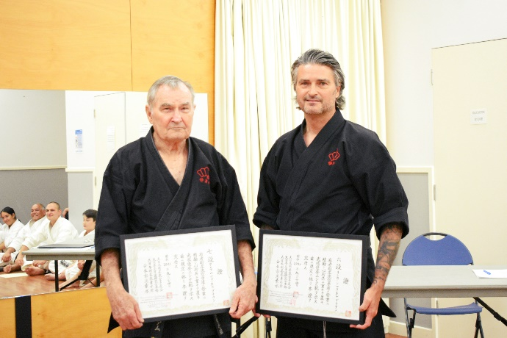
Shihan Graeme and Sensei Lincoln holding their new Dan Certificates issued by Christophor Clifford, Kaicho of Chris Clifford Goju Ryu Karate do.

BLACK BELT ADDITIONS AND CHANGES
At our last training night of 2021 we included a full Black Belt grading.
Asanka Silva was promoted to 3rd Dan (Sandan)
Sean Carville was promoted to 2nd Dan (Nidan)
Jake Daglis, Jack Daws and Daniella Craig were all up graded from Junior Black Belt to full adult 1st Dan (Shodan)
Anthony Balia and Tara Balia from the Westmeadows dojo, and Jordan Saykarosky from the Hillside dojo were promoted to 1st Dan (Shodan).
The night was very full of action and so we were unable to read out the Black Belt Assignments from Anthony, Tara and Jordan. These assignments have now been uploaded to our website www.goju.com.au
However for convenience their assignments are published below. Please read these assignments as they show the dedication and progress they have made along their personal karate journey.
Well done to all those who successfully tested and received new Black Belt grades.
The club now has 16 Black Belts:- Eleven 1st Dans, one 2nd dan, two 3rd dans, one 6th dan and one 7th dan.
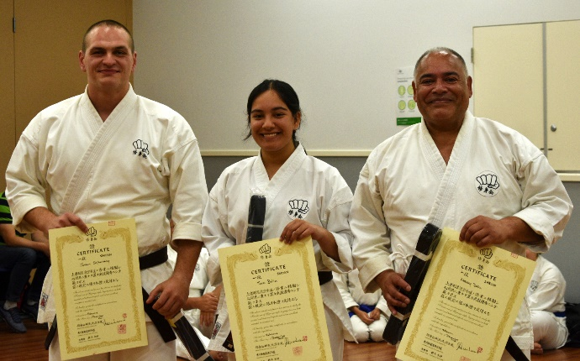
New 1st Dans Jordan, Tara and Anthony

IMPORTANT NEWS : FEES
This year there will be no increase in training fees or Membership Fees.,
Would all members please pay their fees promptly on the FIRST training night of each month. (Which means of course, bring your fees to the first night back in class).

PAYING FEES
We accept cash or cheque for any fees. You can also pay your fees via direct banking on the internet.
We bank with BANKAUSTRALIA
BSB 803-140
Name of Account: Japanese Karate Academy Inc.
Account Number: 14069239
When making payments please add a description (i.e. Training Fees), and send Shihan a short email (shushin@bigpond.com) saying you have made the payment.

2022 CLASSES START DATES

Hillside Dojo (Banchory Ave, Hillside): Tuesday 1st February at 7.00pm.

Westmeadows Hombu Dojo
Wednesday 2nd February at 7.00pm.

Westmeadows Hall Dojo (Raleigh St Westmeadows): Monday, 7th February at 7.00 pm

COMINGS AND GOINGS
As is usual in martial arts there was the usual comings and goings throughout the year. The continuous lockdowns, restrictions on numbers and general uncertainty caused a few members to fall by the wayside.

We received a large number of student enquiries, mainly from our internet presence, but most people are “shopping” only. A few came to class and left after seeing the karate we practiced. Some stayed for a few lessons. By far the majority of enquiries were from parents looking to have their children join the club. But these enquiries generally were for children aged between 4 years and 7 years.
We now have a minimum age of 11 years to join Shushinkai.

However, a few stalwarts joined us and continue to practice. Welcome!! I hope you continue to enjoy your journey with us.

THE YEAR AHEAD IN SHÚSHIN KAI
The year ahead will hopefully be free of lockdowns and interruptions. We look forward to everybody enjoying and progressing their karate. The year ahead will be positive!!!

See you back in class………..

Shihan Graeme
Jan 2022

What Karate Means to Me By Anthony Balia
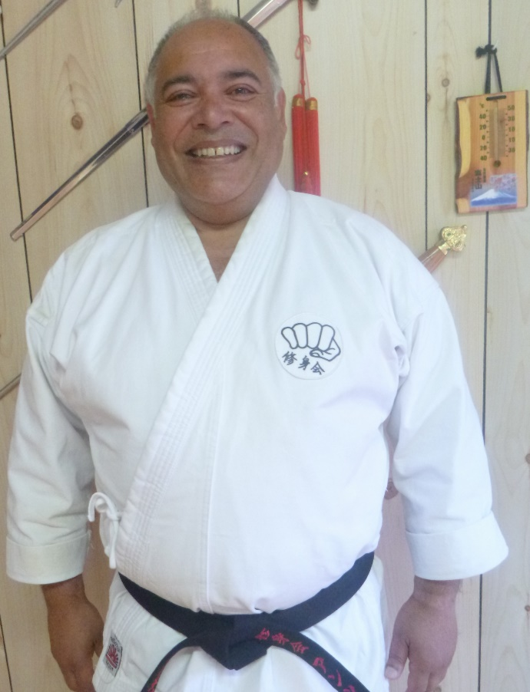
In a simple response, it is part of my way of life, which has progressed from the first time I stepped into a Dojo at the age of 15. I am now 58 years old, a far cry from the teenager that first joined karate.
There has been a lot of water under the bridge since then, especially since this is the first time I’m attempting my Shodan. 43 years is a long time when I reminisce back and think, why didn’t I get a black belt in my 20’s doing Shotokan, or in my 30’s when doing Wado Ryu ? I even attempted Aikido for 12 months. I was not ready and even today I feel unworthy in the honour of being invited into the black belt family. One thing I can say, is that only in the years since I became a student of Goju Ryu and joined the Shushin Kai family, have I had the support and instruction to get me to the stage I am today.
My journey back into Karate started while on a family holiday when we visited Tokyo in 2016. I’ve always had an interest in martial arts and suggested to my wife Shradha that we should visit the Tokyo Budokan (not to be confused with the Nippon Budokan), one of the main martial arts venues in Japan. We had already seen a lot of temples and other tourist sites. It was a feeling of awe watching a traditional Kendo class and a master instructing a student in Kyudo (Japanese archery). The etiquette and respect, which I used to experience on entering a dojo, came flooding back. My emotion and my comment to my wife, “why did I stop karate ?”, resulted in me joining Shushin Kai with my daughter Tara.
Shradha had contacted Shihan, based on a recommendation from one of her close friends, and also scrutinising Shushin Kai’s Facebook page and website. She was impressed both with the presentation and the chat she had with Shihan. It was a total surprise when she told me what she had done. Her only comment to me was that, she knew I enjoyed martial arts and it was time to get back into it for my sanity (and hers). What can I say but wives are always right !
My first class with Shihan was on Monday 17th October 2016. It was a life changing event for me. I joined our Dojo with Tara as a father and daughter team, but to me it was more than that. It’s been almost 5 years now and in that time Karate has made me change many behaviours that have been detrimental to my health and mental state. I have lost almost 20kgs. My sugar and blood pressure levels have come under control, not to mention my physical fitness and flexibility. I know I need to do more on this side, but I am confident my karate journey will help me in achieving my goals.
The physical is not the only part of me that has benefited from karate. The mental and spiritual side has also evolved. Karate brings me peace, both when I train in the dojo or by myself. Life is hectic at the best of times. Karate has helped me to manage my stress. As part of my morning routine, to walk my adorable border collie Cassie, I’ve incorporated practising my katas with a range of meditative music playlists. I’ve found it so peaceful doing my katas with the background of the early morning sun breaking with the rising mist in the park. It is such a great start to the day that it really is life’s high-pressure release valve. Karate has helped me to clear my mind and relax. There is always Shihan’s echo in the background, “.. relax Anthony, you’re too tense”.
So “What does Karate mean to me ?“. Again - It is part of my life and my sanity. Thankyou Shihan and Sensei and our Shushin Kai family for being part of my (our) journey.

By Anthony Balia 10th November 2021
Anthony Balia began training at Shushin Kai karatedo on 1st November 2016, at age 54 years. He was graded to Shodan on 16th December 2021, at age 59 years.

What Karate Means to me by Tara Balia
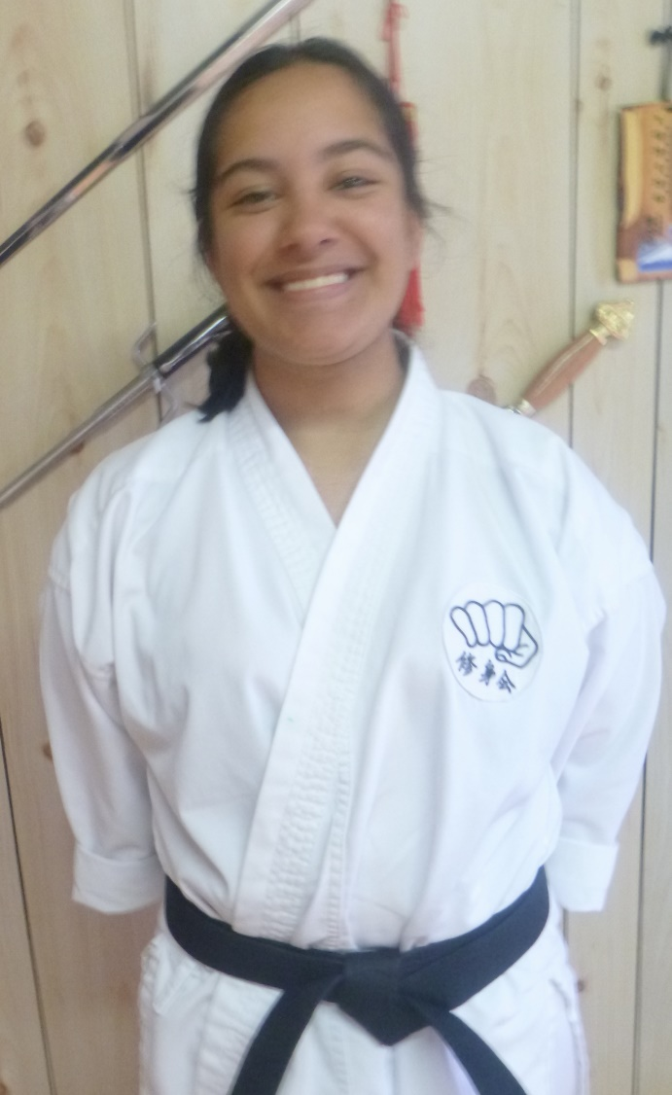

After visiting Japan in October 2016, Dad was enthusiastic to start Karate and I joined with him as it would be a new and different experience. Little did I know how much it would influence the person I am today.

Eight months into my Karate journey as a white belt, I filmed a ‘pep talk’ for a school assignment about the importance of persistence and being the best, you can be no matter your belt colour. Now, re-watching it whilst preparing for my black belt grading, I have realised how much I have grown as a person and as a member of Shushin Kai Goju Ryu Karate-do.

The club has provided me with confidence and life skills, no other sport or activity I have participated in has given me. It has also taught me about my strength and what I am capable of. I have always been a quiet person, and whilst being a safe and welcoming environment, our karate club has educated me about the importance of self-awareness, using my voice, sharing my learning by teaching others, and protecting myself. Members, especially of the Westmeadows dojo have become an important aspect of my karate journey as they have mentored me and are the reason learning and coming to karate is so enjoyable.

Karate has kept me going. I have realised going to karate on days when I am tired or down, I feel uplifted and in a better mood. Karate has provided me with grounding and discipline which has assisted me in high school with my attitude and focus towards my learning. It has taught me to focus on one task and always put my best effort in which is especially important as I am starting VCE next year and can now get a part-time job.

Training has also made me a healthier person, helping with my fitness and flexibility. I have always had asthma and I didn’t believe Shihan when he said karate could cure it. Now, after four years of kata and breathing exercises, I rarely get exercise induced asthma. Karate has improved my lung capacity and taught me how to breathe properly. I can now go for a run, do rowing or go to PE classes without any breathing difficulties.

One of the most important messages I have taken from my karate journey which I can apply to my everyday life, is ‘Spirit Before Technique’. It has taught me that having passion and putting in your best effort is what gets you over the line and is the key to success.

Even at the age of 15, karate has changed my outlook on life. I believe Karate has not only taught me about my strength and capabilities but has made me better as a whole person.

I need to ensure as my academic workload increases, I continue training as coming to karate allows me to centre myself and release stress.

Overall, the reason karate means so much to me is because Shihan and Sensei Lincoln’s passion and knowledge means I can constantly improve my karate, myself spiritually, and there is always more to learn.

By Tara Balia 10th November 2021
Tara Balia began training at karatedo on 17th October, 2016, at age 13 years. She was graded to Shodan on 16th December, 2021, aged 15 years.

What Karate Means to Me By Jordan Saykarosky
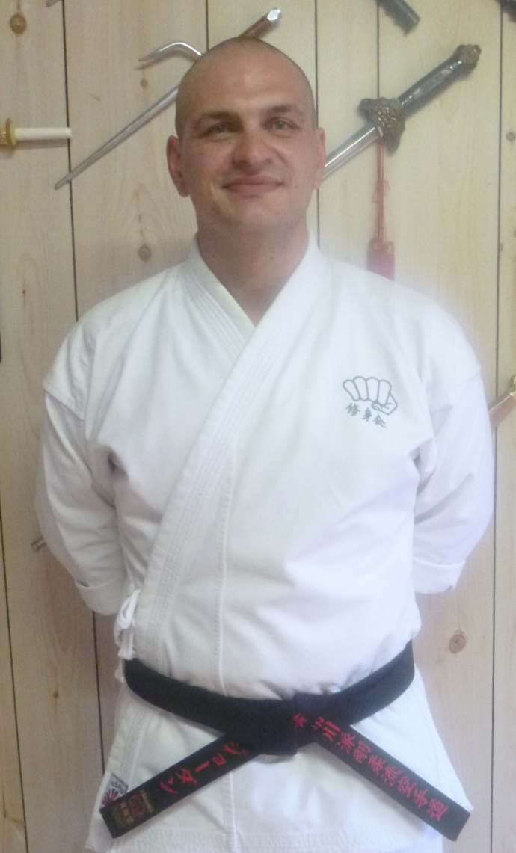
My karate journey began when I was just 8 years of age, with a best mate of mine from primary school. I started with Gojukensha back in 1995. I really enjoyed kata and going to class mingling with others and learning. I was with the club for approximately 3 years, which I gained my 1st kyu and then left to play other sports.
In 2007, I found my old karate club and wanted to achieve my dan grading. I would attend as many classes as I could, up to 3 to 4 times a week. I loved it and had that drive to learn. I spent the next few years picking my instructors brain and assisted with classes to learn and teach others.
It was then after 3 and a half years on I wanted to explore other martial arts, to see what other arts had to offer. I did this for some time then work commitments and life took over, but here I am back at doing karate once again with Shushin Kai.
I now ask myself writing this essay what does karate mean to me and why have I kept going back to karate all these years on and off. Karate has taught me lots of life skills throughout my life and it’s the simplest things when I look back. It has taught me to respect others, be resilient, have discipline and be kind to others just like we do in in every class that we attend.
Whether in the dojo or at work, I have applied the things I have learnt in karate such as interacting with new people, being patient with other and assisting people with problems. Karate has most especially helped within my current role having to deal with setbacks on certain work tasks whilst remaining calm and disciplined in what can very tense and difficult situations.
Karate has enriched my life and others around me. I feel confident in protecting myself my loved ones and the team I work with, but also being able to help others to protect themselves giving and them confidence.
That confidence over time has allowed me to be more self-aware as a person and then being able to help others not just in the dojo but life itself. I believe that every time I attend a class I take away a little something that makes me be a wiser person and do my best to be a better person in my everyday life.
I find that that I also need to be confident and aware in the dojo to show the juniors to be confident and defeat setbacks by being a role model to them, to improve themselves as a person as they grow into an adult life. Those words that our sensei or shihan tells us in class about everyday life you take that on board and apply it into your karate and life.
The future for me in karate I cannot possibly know, but I will continue to study the complexities of karate as it means a lot to me. As I have progressed and finally achieved my Dan grading once again, means that gates of exploring have re-opened as it means time to explore everything we learn in-depth.
I think I have possibly found my niche karate school, I do intend to pick the brains of my instructors, learn more of our schools masters and hopefully progress and evolve in my karate. I hope that in the future I can learn with other black belts in the school and teach others what I have learnt through my years and watch their progress on their black belt journeys.

By Jordan Saykarosky 21st August 2021
Jordan Saykarosky began training at Shushin Kai karatedo on 10th July, 2018, at age 33 years. He was graded to Shodan)on 16th December 2021, at age 36 years.

