SHÚSHIN KAI GOJU RYU KARATE

JANUARY, 2021 No. 33

kiai !!!!

THE 2020 YEAR
Well, the year 2020 was certainly a difficult year. As we all know the Coronavirus pandemic caused havoc across the world. Here in Melbourne, we had the toughest lock down in the world and as a result, we eliminated the virus from our state. (Although as I write this, we have another series of infections caused through transmissions from Sydney’s Northern Beaches.) Let’s hope vaccinations and safe protocols save us from any more virus outbreaks.
The virus struck Melbourne in force in March and so our dojos voluntarily closed on March 23rd. We reopened for a few classes in June, and then the second wave hit. We went into lockdown and karate classes ceased again. The dojos only reopened in time for us to run for 3 weeks before the end of the year.

INITIATIVES WE TOOK
Initially we thought the dojo closures would be short lived so we started by sending members karate and martial arts documents and articles. The Black Belt group received highly technical articles related to the deeper practice of Goju-Ryu karate.
When the second lockdown started, we introduced a new Facebook page for Black Belts. We also asked interested members of the club to make a video of themselves performing a kata and send it in for feedback from the Black Belts. We loaded the katas sent in on our Black Belt page, and all the Black Belts wrote advice and corrections. These were then sent privately to the member who sent in the video. Not everybody sent in videos, but those who did received valuable feedback.
Deep into the lockdown we decided to introduce Zoom classes. Monday nights was for Black Belts, Wednesday for all members, and Thursday for Black and Brown belts.
Many of our members got involved in this initiative and those who demonstrated their katas all improved a great deal, despite the limited instruction possible via the internet. But, it showed which of our members were really supporting the club, and trying hard to improve and progress. Most of the members

in the kyu grade area were rewarded with a grading at the end of the year.
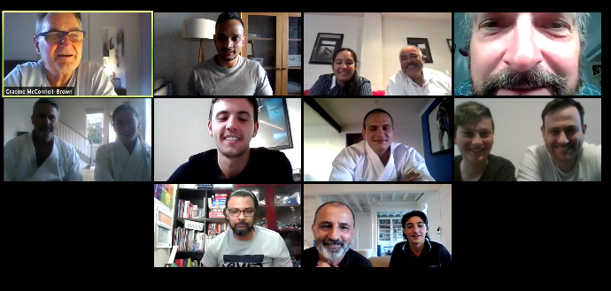

This pic shows our final Zoom class held in 2020, for senior grades.

I would like to thank every body who joined in these ways of practicing and keeping their karate alive. I particularly want to thank our Black Belt group, because most of the them attended 3 classes a week. Your support and enthusiastic contributions were in the best tradition of karate, and I am so proud of you for your efforts for the club and its members.
Classes resumed after the virus was suppressed in Victoria and we had a very good 3 weeks of class in December. Due to the long break, we began slowly for these classes to allow members to regain lost fitness!! To all those who returned, thank you!! It was great to have you back. Unfortunately, we lost about 5 members during the lockdown. But we did gain a number of new members, so welcome to you and we hope you enjoy your future karate journey.
So that was our 2020!! Even our Annual General Meeting was held on Zoom, so thank goodness for technology. Many martial arts schools suffered greatly, some even closing forever through the loss of students and income. Fortunately, we as a not-for-profit group survived basically intact, and in a good financial position.

GRADINGS
Normally we have 3 gradings per year plus a Black Belt grading at our Annual Training Day in October. With our classes in turmoil this year we were only able to have two separate gradings just before Christmas. At the Hillside dojo on December, 17th we held a grading for kyu grades. The grading was made available to members who had attended the various activities described earlier. We also held a grading at the Westmeadows dojo on 18th December, and this included a Black Belt grading for 1st kyu’s who put in the required efforts for a grading. This included extra classes throughout December.

The grading results were;-
Hillside Dojo
Jordan Saykarosky to 1st kyu
Isha Bangara to 6th Kyu
Sanindu Somarathna to 6th kyu
Michael McLaughlin to 6th kyu
Jacqueline Scheicher to 7th Kyu
Westmeadows Dojo
Tara Balia to 1st kyu
Anthony Balia to 1st kyu

New belts and Certificates will be awarded on the first night back in class in 2021.

BLACK BELT GRADING
On the last night for 2020, held at the Westmeadows Dojo, we promoted 2 more members to 1st Dan (Shodan) Black Belt.
After years of study, practice, disappointment, ups and downs and quite a bit of critical feedback, Craig Smith and Daniella Smith from the Hillside dojo achieved their coveted Black Belts. Although the preparation for them was different because of limited face to face training opportunities, the test was the same as for previous Black Belt gradings. Due to government imposed “no contact” requirements, we did not have sparring, but we actually increased the emphasis on form, kata, attendance and contribution to the club. At the grading their assignments “What Karate Means to Me” were read out. These assignments were accepted and can now be viewed on our website.
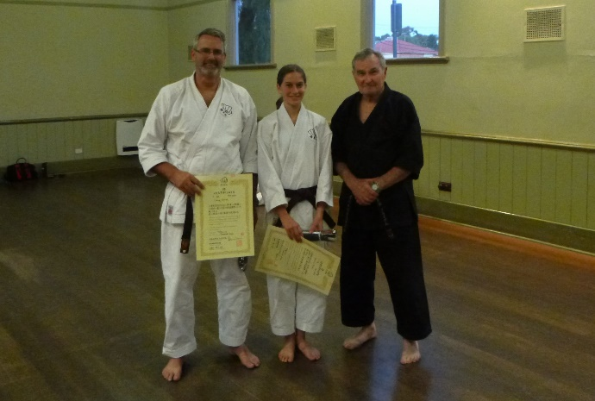
This pic shows Craig and Daniella with Graeme Shihan after receiving their Shodan Certificates and new Black Belts

LAST NIGHT OF TRAINING 2020 - HILLSIDE
On 17th December we had our last night of training for the year at the Hillside dojo. It was great to train again with members who had missed almost a whole year of face-to-face classes. Hopefully more of our members will return in 2021.
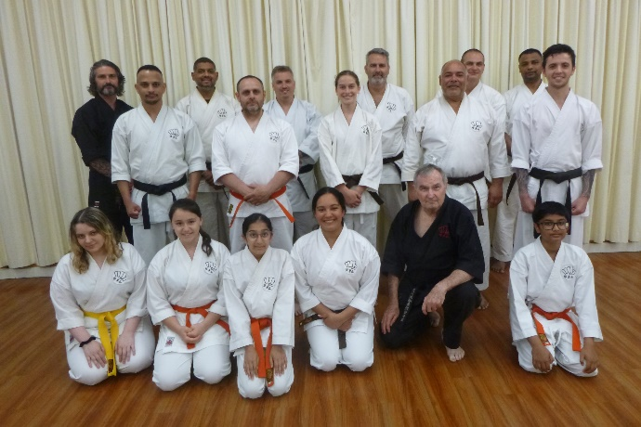
This pic shows our last class at Hillside for 2020. It was terrific to come together at the grading night to conclude our training for the year!!! To observe COVID-19 protocols, we all held our breath.

LAST NIGHT OF TRAINING 2020 - WESTMEADOWS
On 18th December for the first time in over 20 years, we had a separate final night for 2020 at our Westmeadows dojo. Usually we have a combined dojo night at Hillside which includes a full end of year grading. Because of restriction on numbers in the dojos, we decided to split the classes.
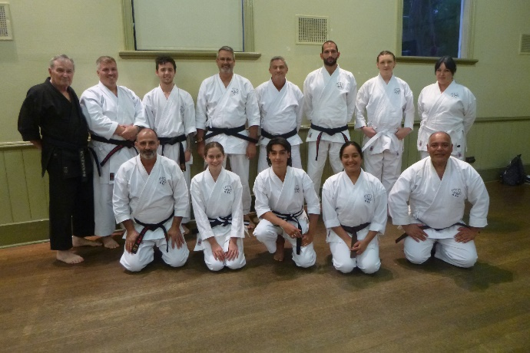
This pic shows the class at the end of 2020 in Westmeadows (Still holding our breath !!)

STUDENT OF THE YEAR AWARD
Every year we nominate one student to be awarded our “Student of the Year” award. This year we were really happy to present this award to Isha Bangara from the Hillside dojo. Isha is always in class, trying her best at all times. Isha is not known for being noisey, but makes up for it by trying hard and joining in all our activities. In 2020 Isha sent in multiple videos of her kata for the Black Belts to comment on, and when we introduced Zoom classes, there she was every night either demonstrating or just joining in the class and discussions. Well done Isha!! Keep up the good work and continue to enjoy your karate journey!!
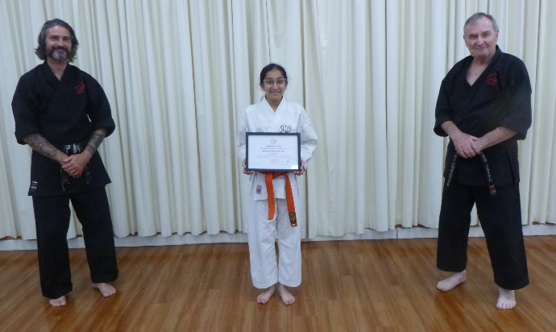Here is Isha with her “Student of the Year “ award for 2020. With Isha, properly socially distancing are Lincoln Sensei, and Graeme, Shihan

CLUB EVENTS CANCELLED IN 2020
The year saw some regular events cancelled. Usually, we have 3 gradings a year, but this year we had just one. Some members who would have had substantial promotions unfortunately missed out.
Our Annual Training Day traditionally held on the first Saturday of October was cancelled. This all-day event is designed to expose members to karate trainings not covered in evening classes and is presented in a seminar format. The day includes an inter-dojo kumite (sparring) competition for both seniors and Juniors, leading to the awarding of “Club Kumite Champion” of the year. We also conduct our yearly Black Belt promotions on this day.
Every year we have a Black Belt only dinner at Chiba Japanese restaurant in Moonee Ponds to welcome new Black Belts to the group. This year, no dinner!! (and no wasabi challenge).
As a tradition at the end of each year we have a raffle or chocolate drive to raise money for the club. This year we did not have this either.
Just prior to Christmas each year we have a special family day at Brimbank Park. We have lunch, and games for the juniors and crazy adults. This event was also cancelled this year.
Your instructors usually travel to Japan each year, or our teachers come here. Again, due to the suspension of international travel, this did not happen either!!
So, 2020, although generally survivable for us saw many activities and training cancelled. Hopefully 2020 is now well and truly behind us, and the future will be bigger and better!!!!

CLASSES RESUMING 2021
So, here is the news everybody wants. Please read the following very carefully. Arrangements at both dojos have changed.

WESTMEADOWS
Venue:- Westmeadows Public Hall, Raleigh St, Westmeadows.
Classes resume on Monday 1st February at 7pm to 9pm, Mondays and Fridays.

Please note that Wednesday night classes at the hombu dojo at my home will continue but will be by invitation only. The dojo is not big enough for class sizes over eight under current Covid-19 rules. We will return to regular Wednesday night classes at my place if circumstances permit, given ongoing changes due to Covid-19.

HILLSIDE
Venue:- Banchory Community Center, Banchory Ave, Hillside
Classes resume on Tuesdays and Thursdays as follows:
Tuesdays, 7,30pm to 9.30pm (NOTE NEW TIME !!!)
Thursdays, 7.00pm to 9.00pm
Melton Council require a one-hour gap between classes/activities in its facilities to allow for cleaning of the spaces and equipment. We have absolutely no say in these Covid safe rules directed by Council. On Thursdays, there is no class or activity before us so we can start at our regular time of 7pm. However, on Tuesdays there is a dance class before us which usually finishes at 7pm. They are now required to finish earlier at 6.30pm and we are required to start half an hour later at 7.30pm

We have been advised by Melton Council that the 1 hour between classes will be rescinded and our classes will return to a 7.00pm start when the Coronavirus vaccine is released by the government, and inoculations begin. Council anticipates this will be around April. We will keep you informed about this.

COVID SAFE CLUB OPERATIONS
We will be continuing to observe the covid safe rules at both dojos. Currently Hillside has a cap of 22 in the class. As Westmeadows is a larger facility, our maximum number is 35. Hillside requires QR code sign in, whilst at Westmeadows we simply keep a roll. We have all contact information in our club records. All Members and potential members have been issued our Covid Safe Plan which must be observed at all times.

WORKING WITH CHILDREN CHECK
All adult Black Belts are required to obtain a Working With Children Check through the state government. This has nearly been completed.

CHILD SAFE STANDARDS
All adult Black Belts are required to read and acknowledge their acceptance of Victoria’s Child Safe Standards. This is being organized by Sensei Lincoln, and as of the date of writing, 3 are yet to complete this task, which MUST be done before classes resume.

WEBSITE
Our website Uwww.goju.com.au continues to present our club to the public. The original website was launched in January 1999. Since then, the site has received many thousands of visits,
We also run a Facebook page open to all members, and to the public, as well as a page for our Black Belts which is private.
Many thanks to Suraj as administrator,

IMPORTANT NEWS : FEES
Once again, there will be no increase in training fees or Membership Fees for 2021. Training fees have remained unchanged for the last 12 years!!!
Would all members please pay their fees promptly on the FIRST training night of each month. (Which means of course, bring your fees to the first night back in class).

PAYING FEES
We accept cash or cheque for any fees. You can also pay your fees via direct banking on the internet.
We bank with BANKAUSTRALIA
BSB 803-140
Name of Account: Japanese Karate Academy Inc.
Account Number: 14069239
When making payments please add a description (i.e. Membership Fees), and send Shihan a short email (shushin@bigpond.com) saying you have made the payment.

COMINGS AND GOINGS
As is usual in martial arts there were the usual comings and goings throughout the year.

We received a large number of student enquiries, mainly from our internet presence, but most people are “shopping” only. A few came to class and left after seeing the karate we practiced. Some stayed for a few lessons. By far the majority of enquiries were from parents looking to have their children join the club. But these enquiries generally were for children aged between 4 years and 7 years. We have a minimum age of 9 years to join Shushinkai.

However, a few stalwarts joined us and continue to practice. Welcome!! I hope you continue to enjoy your journey with us.

Particularly I would like to welcome Shodans Jacob Vella and Frank Dellovoet back to the club after a period of absence!! Welcome home!!

MESSAGE FROM SENSEI LINCOLN
Needless to say that 2020 gave us “unprecedented times” but to me, nothing signifies this more than the way our club stuck together over the 9 months of lockdown.

Whilst we all thought in March that we’d simply have a month off class whilst the virus passed, our motivation was strong. However, as we moved in to June, July etc, it became clear that we’d be apart for a lot longer and that we’d have to come up with a concept to keep everyone and the club together.

Incorporating virtual classes via ZOOM gave us all an opportunity to stay in touch with not only our Karate, but our club and I know that this served as a motivating factor for a number of our students.

I’m pleased to see a number of our juniors “grow” during the year via these ZOOM sessions and start to take a more senior role around the club.

The energy everyone showed on those sessions was sensational and made both myself and Shihan Graeme proud to be part of this club.

My motto has always been “Go hard or go home”. Thanks to the Coronavirus, we went hard and stayed home !

A special shout out to our karate friends in Japan, England and South Africa who at the time of writing are doing it really tough with continued lockdowns. You have the thoughts and best wishes from Shushin Kai !

THE YEAR AHEAD IN SHÚSHIN KAI
I am looking forward with great anticipation to seeing you all when class recommences. I am sure 2021 will be exciting and productive for everybody!!!

See you back in class………..

Shihan Graeme グライアム
January 2021

