SHÚSHIN KAI GOJU RYU KARATE

JANUARY, 2018 No. 30

kiai !!!!

2017 BREAKUP & GRADING RESULTS
A successful Breakup night was held at the Hillside dojo on 19P^{thP} December. Members from the Westmeadows and Hillside dojos came together for a combined night

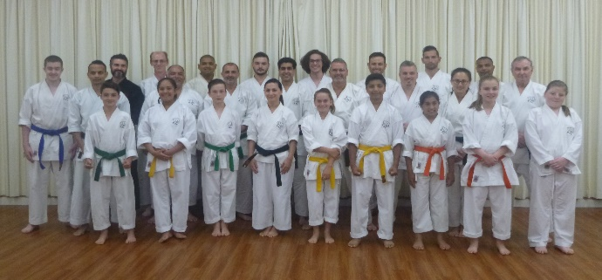

Grading results………

Promoted to 2nd Kyu Brown Belt
Prashant Sehgal (Westmeadows)
Stephen Afflitto (Westmeadows)
Nathan Daws (Westmeadows)

Promoted to 3rd kyu Kyu Brown Belt
Jake Daglis (Westmeadows)
Con Daglis (Westmeadows)
Jack Daws (Westmeadows)

Promoted to 4th Kyu Green Belt
Nicolas Iannou (Hillside)

Promoted to 5th Kyu Blue Belt
Felicity Darcay (Hillside)
Daniella Smith (Hillside)
Javeria Naved (Hillside)

Promoted to 6th Kyu Orange Belt
Tara Balia (Westmeadows)
Anthony Balia (Westmeadows)
Janindu Somarathna (Hillside)
Chandralal Somarathna (Hillside)

Promoted to 8th Kyu
Lillijana Stagliano (Hillside)

New belts and Certificates will be awarded on the first night back in class.

It was agreed by all seniors that this was the best grading we have ever held in trms of overall standard. There were no students just scraping through as in previous gradings. Every single member who passed the tests demonstrated a dedication and commitment to trying their best, and this showed up in every aspect of the grading.
The sparring was also of high standard. Sparring is only required at Brown belt level, but every member in attendance put on their gloves and joined in without being asked. Well done.

Just looking at the results it is very obvious that the club is going strong and every current member is striving to achieve excellence!!!

XMAS BBQ
On 10th December the club held its Annual Xmas function at Brimbank Park. This was chosen this year because of safety concerns with young folk around the Maribynong River, the easier to access area and amenities for visitors. Those with excess energy played a game of friendly cricket. Last year we had a very poor turn up but this year the numbers were excellent with pretty much all members and their families attending. Many thanks to Suraj who organised the event for everyone.
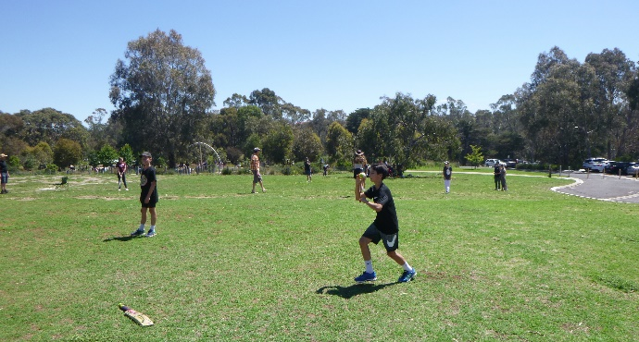

STUDENT OF THE YEAR
Once again we had our Student of the Year Award presented on our breakup night. We are pleased to announce this year’s winner was Jack Daws from our Westmeadows dojo. Jack rarely misses a class and has shown great improvement and dedication to karate studies. We are looking forward to Jake continuing his karate career well into the future and realizing his full potential. Well done Jack !!!
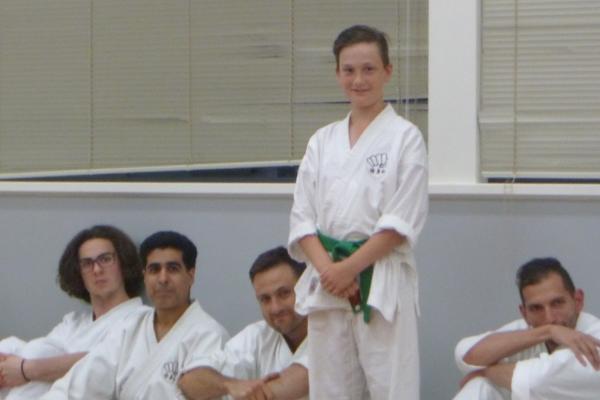
Jack Daws the 2017 recipient of our Student of the Year Award.

ANNUAL TRAINING DAY 2015
On Saturday, 7th October we held our 13th Annual Training Day and Competition at the Westmeadows dojo Thank you all for attending and helping to make the day enjoyable and productive!!
Before each session during the day Erjan and Sophie took the class for warmups and stretching. This was part of their Black Belt grading assessment.
In the first two morning sessions Lincoln Sensei taught Naihanchin Shodan kata and applications.
These sessions were revisions and applications of last year’s sessions.
This was followed by the Black Belt kata grading test for Sophie and Erjan. Firstly Sophie’s assignment “What karate means to me” was read out to the class. Her essay was thoughtfully written and showed a great insight into Sophie’s personal karate journey. The assignment is now available to read on our website. After this, both Erjan and Sophie were were called upon to demonstrate a number of katas to the whole class in a very formal environment. They both did well and Erjan successfully converted his Junior Shodan rank into full Shodan (1st Dan), and Sophie successfully achieved her Black Belt.
After lunch Lincoln Sensei conducted the 13th Annual Club Championship tournament. Unfortunately, a small number of members elected to not compete at the last moment which unfortunately affected the conduct of the tournament, but not the standard displayed by our competitors.
Winners are shown below.

After the tournament Lincoln sensei took the class for a revision session on session on “hands free” bunkai. Shihan Graeme then took the class for a session on the Art of Kiai.. Then followed a session on empi waza (elbow techniques) with Lincoln sensei.
The day wound down with presentations of trophies and medals for tournament winners and Certificates and Black Bets for our new Shodans.

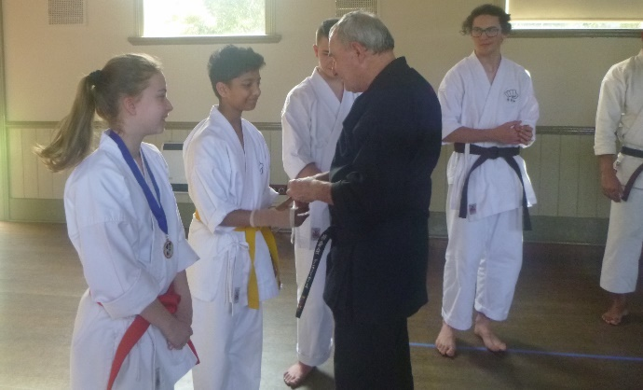

Felicity Darcay and Janindu Somarathna tied for first place in our Junior Division of the Training Day tournament. Here they are being presented with their medals by Graeme Shihan.

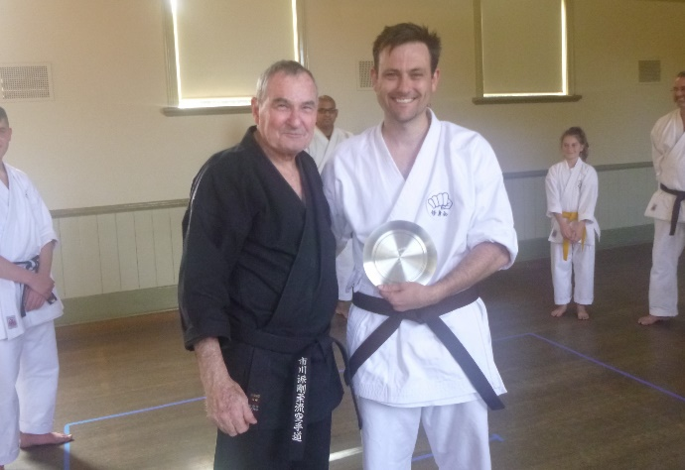

Club Champion for 2017 was Nathan Daws here with his trophy. As a young boy Nathan trained with us many years ago at Tullamarine. He returned to the club a couple of years ago and restarted his karate journey.

Thank you to everybody who came along to support the event, and particularly to Suraj who organized life saving food and drinks, and Sensei Lincoln who organized the whole day plus taught and conducted and refereed the sparring competition. Thanks also to Vicki, Suraj and Sophie who officiated as timekeepers and scorers.

SHUSHIN KAI CLUB CHAMPION
Our Shushin Kai Kumite Championship was again conducted with great spirit and skills Nathan Daws from the Westmeadows dojo was the 2017 winner and was presented with a plate engraved with his victory. Well done Nathan. The tournament incorporated a “grading” or “handicap” system. Lower grades and females received higher scores for fighting higher grades, thus giving everybody a fair chance of winning. The sparring was based on close quarter self defence sparring of 30 seconds duration. This year under strict control rules, the juniors competed for their own winner This year we announced 2 winners because of a tie:-. Felicity Darcay and Janindu Somarathna

NEW DAN GRADES
A major highlight of the day was the promotion of Sophie and Erjan to 1st Dan Black Belt.
Their promotion was very well deserved, so congratulations to you both.
In the evening, after the Training Day, all the Black Belts met for dinner at Chiba Japanese Restaurant in Moonee Ponds.

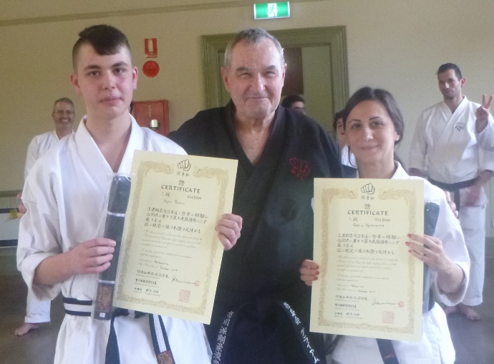
Erjan and Sophie pictured here with their new certificates..

WEBSITE
Our website www.goju.com.au continues to attract visitors and provides an email facility for interested people to contact us with a view to joining. If you have not visited the website, please do so as it is full of good information!!!

FACEBOOK
Our Facebook is ShushinKaiGojuRyuKarate, or there is a live link from the bottom of the Home Page on our website www.goju.com.au
Please visit our Facebook page regularly as it carries more up to date, day to day information than the website. Please “like” us, share pages and invite your friends to visit and “like” us. Please feel free to make entries and comments.

FUNDRAISING
To meet the costs of running the club members have been busy fundraising. This year we held another chocolate drive. Thank you to everybody who supported us. We are a very small club and have some major fixed costs (particularly insurance and advertising) that we cannot cover with fees alone. A huge thanks also to Suraj who administers the choco drives.

JAPAN TRAINING
In September 2017 Shihan Graeme and Sophie Karavaras visited Japan to train with our teacher, Tsubamoto Sensei, 10th Dan. We trained in all regular Shigaku Kan classes and had a number of private sessions with Tsubamoto sensei. Thank you to everybody in Shigaku Kan for making us feel welcome and especially to Tsubamoto sensei for his teachings. In 2018 Sensei Lincoln and Shihan Graeme are planning to visit Shigaku Kan again.

IMPORTANT NEWS : FEES
This year once again (8th year), there will be no increase in training fees.

Given that we are not increasing training fees would all members please pay their fees promptly on the FIRST training night of each month. (Which means of course, bring your fees to the first night back in class).

PAYING FEES
We accept cash or cheque for any fees.
You can also pay your fees via direct banking on the internet.
Ask Shihan for the banking details.

2018 CLASSES START DATES

Hillside Dojo (Banchory Community Centre, Banchory Ave, Hillside): Thursday 1st February at 7.00pm.

Westmeadows dojo, (Westmeadows Hall, Raleigh St, Westmeadows) : Monday, 5th February, at 7.00 pm

Westmeadows Dojo (Home dojo, present members only) : Wednesday, 7th February at 7.00 pm

THE YEAR AHEAD IN SHÚSHINKAI
We are looking forward with great anticipation to seeing you all when class recommences. We are sure 2018 will be exciting and productive for everybody!!!
See you back in class………..
Shihan Graeme
Sensei Lincoln
January, 2018

